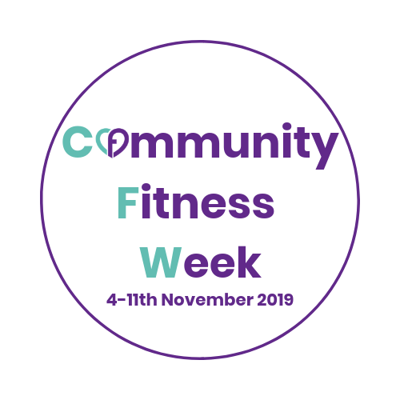

For immediate release
Press Release Contact name/business:
Email:
Telephone number:
Website:

First ever community fitness week launches across the U.K this November

Community Fitness Week is a brand new initiative coming to (insert location) as part of a national campaign to raise the awareness and use of fitness in community venues across the UK.

Community fitness instructors from all regions are signing up to the week, with the campaign for this year named #fitnessforfood. Fitness instructors will run their regular classes with an emphasis on encouraging new participants to attend and try something new. Every class goer, new or regular, will be asked to bring a non-perishable item of food to their class as well, which the instructor will deliver to a local food bank.

With 1000 instructors expected to sign up, the #fitnessforfood drive is set to make a huge positive impact on local communities.

*Local instructor should insert information here on themselves and where their classes will be taking place during community fitness week. It is also advisable for the local instructor to add a comment here on their own personal view of the initiative and the benefits they feel it will bring to their individual community*

Editors notes:

- Photos are attached
- Add in any awards you have won

